**How to edit ontologies in Protégé using ODK**

Add annotations for your ontology (required by robot) as these are metadata for your ontology:

* Title <http://purl.org/dc/elements/1.1/title>
* Description <http://purl.org/dc/elements/1.1/description>
* Default namespace <http://www.geneontology.org/formats/oboInOwl#default-namespace>
* Version <http://www.geneontology.org/formats/oboInOwl#version>
* License http://purl.org/dc/terms/license   
  [license for AISM for now [www.apache.org/licenses/LICENSE-2.0](http://www.apache.org/licenses/LICENSE-2.0) borrowed from Experimental Factor Ontology <http://www.ebi.ac.uk/efo/efo.owl>, latest available through https://www.ebi.ac.uk/ols/ontologies]

All these should be defined as **‘Annotation properties’** to begin with.

Setup Protégé to auto generate IRI-s:

File > Preferences > New entities

Specified IRI: [http://purl.obolibrary.org/obo/](http://purl.obolibrary.org/obo/AISM)

Set language to ‘en’, digit count to 7

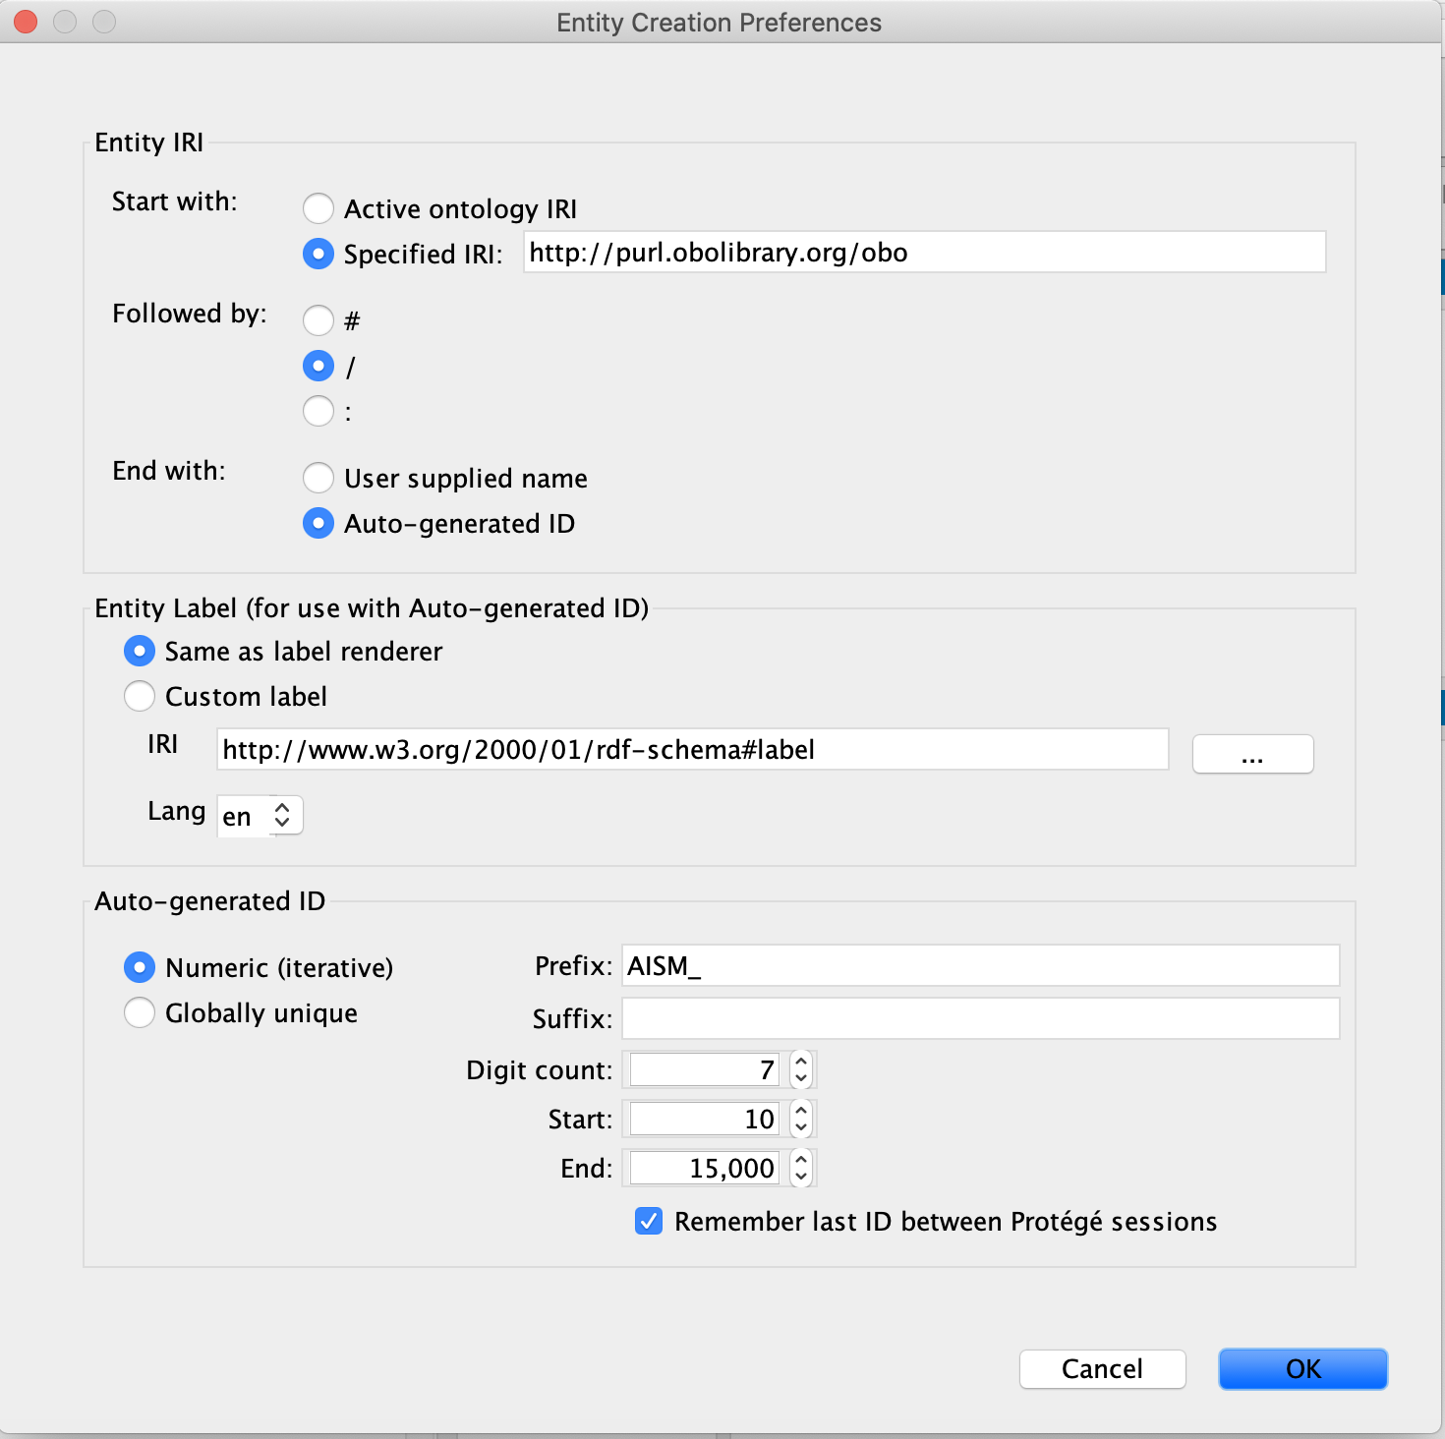

How to import a term from existing ontologies:

**Setup a new import**

1. add imports to src/ontology/aism-odk.yaml

import_group:

products:

- id: ro

- id: uberon

- id: pato

- id: bspo

2. in terminal sh run.sh make update_repo (**in src/ontology**)

I-Miko-mbp:ontology istvanmiko$ sh run.sh make update_repo

3. open aism-edit.owl in text editor add import statement

Prefix(:=<http://purl.obolibrary.org/obo/aism.owl#>)

Prefix(dce:=<http://purl.org/dc/elements/1.1/>)

Prefix(owl:=<http://www.w3.org/2002/07/owl#>)

Prefix(rdf:=<http://www.w3.org/1999/02/22-rdf-syntax-ns#>)

Prefix(xml:=<http://www.w3.org/XML/1998/namespace>)

Prefix(xsd:=<http://www.w3.org/2001/XMLSchema#>)

Prefix(rdfs:=<http://www.w3.org/2000/01/rdf-schema#>)

Prefix(dcterms:=<http://purl.org/dc/terms/>)

Ontology(<http://purl.obolibrary.org/obo/aism.owl>

Import(<http://purl.obolibrary.org/obo/aism/imports/bspo_import.owl>)

Import(<http://purl.obolibrary.org/obo/aism/imports/pato_import.owl>)

Import(<http://purl.obolibrary.org/obo/aism/imports/ro_import.owl>)

Import(<http://purl.obolibrary.org/obo/aism/imports/uberon_import.owl>)

Annotation(dce:description "Ontology about the skeletomuscular system of insects")

Annotation(dce:title "Anatomy Ontology of Insect Skeletomuscular System")

Annotation(dcterms:license <CC-BY>)

4. open catalog-v001.xml in text editor and add import statement

<?xml version="1.0" encoding="UTF-8" standalone="no"?>

<catalog prefer="public" xmlns="urn:oasis:names:tc:entity:xmlns:xml:catalog">

<uri id="User Entered Import Resolution" name="http://purl.obolibrary.org/obo/aism/imports/uberon_import.owl" uri="imports/uberon_import.owl"/>

<uri id="User Entered Import Resolution" name="http://purl.obolibrary.org/obo/aism/imports/uberon_import.obo" uri="imports/uberon_import.obo"/>

<uri id="User Entered Import Resolution" name="http://purl.obolibrary.org/obo/aism/imports/bspo_import.owl" uri="imports/bspo_import.owl"/>

<uri id="User Entered Import Resolution" name="http://purl.obolibrary.org/obo/aism/imports/bspo_import.obo" uri="imports/bspo_import.obo"/>

<uri id="User Entered Import Resolution" name="http://purl.obolibrary.org/obo/aism/imports/pato_import.owl" uri="imports/pato_import.owl"/>

<uri id="User Entered Import Resolution" name="http://purl.obolibrary.org/obo/aism/imports/pato_import.obo" uri="imports/pato_import.obo"/>

<uri id="User Entered Import Resolution" name="http://purl.obolibrary.org/obo/aism/imports/ro_import.owl" uri="imports/ro_import.owl"/>

<uri id="User Entered Import Resolution" name="http://purl.obolibrary.org/obo/aism/imports/ro_import.obo" uri="imports/ro_import.obo"/>

</catalog>

5. terminal sh run.sh make imports/obi_import.owl

I-Miko-mbp:ontology istvanmiko$ ./run.sh make all_imports

6. open maxo-edit.owl in protege and run reasoner to look for unsatisfiable classes

**Once imports are set up**

7. Find your term online and copy its IRI

In Protégé: add subclass

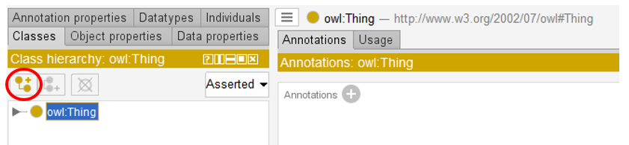

Which opens a new window:

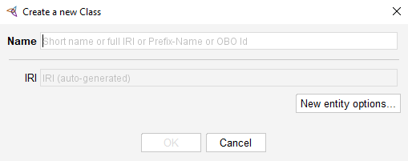

8. Paste your link to the Name field and click OK

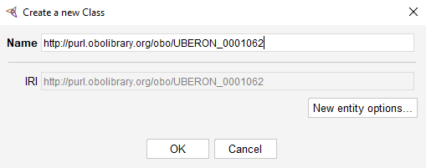

The term will now be listed under Thing.

9. Save the AISM.owl file and run the following script in terminal in the src/ontology folder:

10. ./run.sh make all_imports

If you try to import from a larger ontology (like PR, protein ontology) the process might take an extreme long time and might eventually be terminated (like when I tried to import resilin from PR). In this case, it is perhaps the best to simply start with 7 (without importing the ontology), so the term will have a iri, but will just heng on Thing.